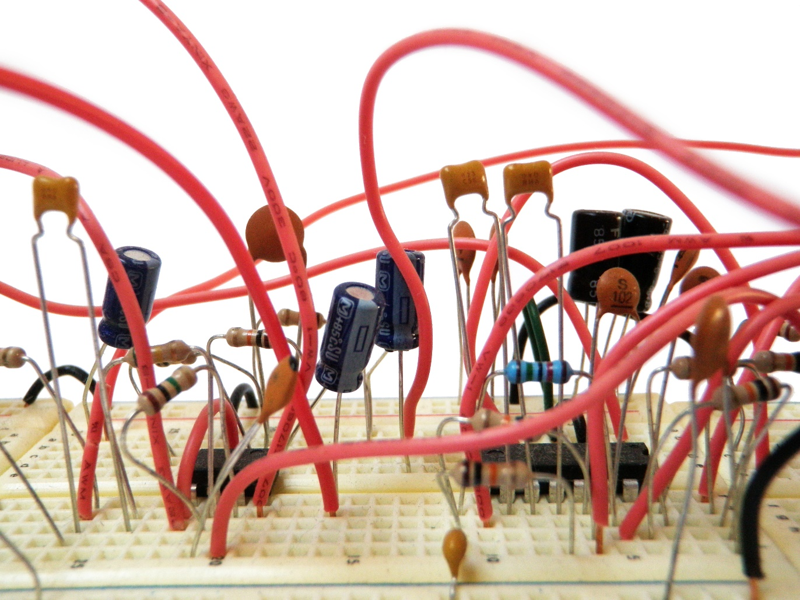

A PROJECT REPORT ON

MOBILE PHONE

DETECTOR CIRCUIT

BY

THUTIPATI APARNA TEJA VARDHINI

B221059

ANALOG ELECTRONIC CIRCUITS

09-11-2022

*DEPARTMENT OF*

ELECTRONICS AND TELECOMMUNICATION ENGINEERING

AIM OF THE EXPERIMENT:

* Design a Circuit that can detect signals in the range of 0.9 GHz to 3GHz mode.

MOTIVATION AND OBJECTIVE:

* This handy, pocket-size mobile transmission detector or sniffer can sense the presence of an activated mobile cell phone from a distance of one and-a-half meters. So it can be used to prevent use of mobile phones in examination halls, confidential rooms, etc. It is also useful for detecting the use of mobile phone for Spying and unauthorized video transmission. The circuit can detect the incoming and outgoing calls, SMS and video transmission even if the mobile phone is kept in the silent mode. The moment the Bug detects RF transmission signal from an activated mobile phone, it starts sounding a beep alarm and the LED blinks

CIRCUIT DIAGRAM:

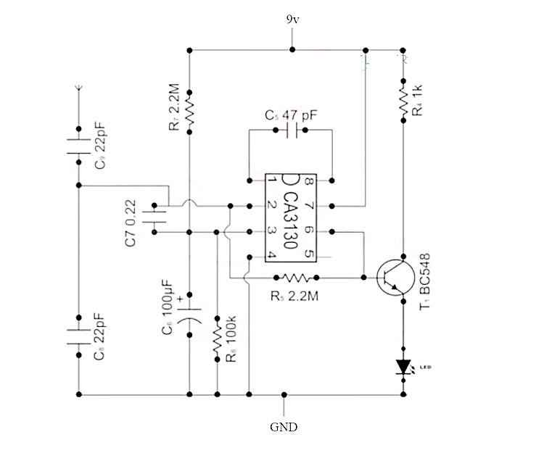

COMPONENTS AND SYSTEMS REQUIRED:

* CA3130 Op-Amp
* Resistor – 2.2M ohm(2)
* Resistor – 100K ohm
* Resistor – 1K ohm
* Capacitor- 22pF(2)
* Capacitor- 0.22nF
* Capacitor- 47pF
* Capacitor-100 micro F
* BC548 NPN Transistor
* LED
* Antenna
* Connecting Wires
* Breadboard
* 9V battery
* Mobile Phone

THEORY:

* This circuit consists of an op-amp with some active-passive components. A LED is used for an indication of the presence of a cellphone or a mobile phone. Op-amp is configured as Frequency Detector and its output is connected to a LED using BJT NPN Transistor. The circuit diagram is shown above. The circuit can be assembled in a breadboard.
* The circuit is built using [**CA3130 Op-Amp**](https://how2electronics.com/lm358-dual-op-amp-features-pins-working-applications/) IC and NPN Transistor [**BC548**](http://pdf.datasheetcatalog.com/datasheets/150/128380_DS.pdf).
* When a mobile phone is active, it radiates RF signal in the form of electromagnetic radiation. When the mobile phone radiates energy in the form of RF signal, Capacitor C2 absorbs it and used as an input to CA3130. The output of CA313O is connected to LED via Transistor which gets turned ON. Then the flashing of LED is observed.

This is how you can make a Mobile Phone Detector Circuit.

SIMULATION AND ITS RESULT:

The Designed Circuit:

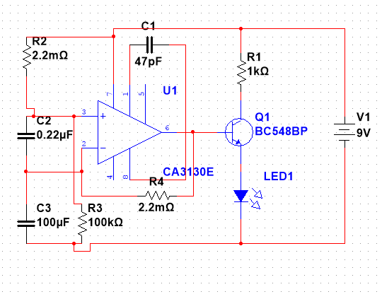

RESULT AFTER SIMULATING:

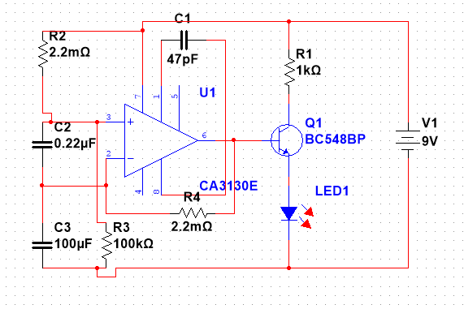

* HERE THE LED IS GLOWING.

EXPERIMENT AND ITS RESULT:

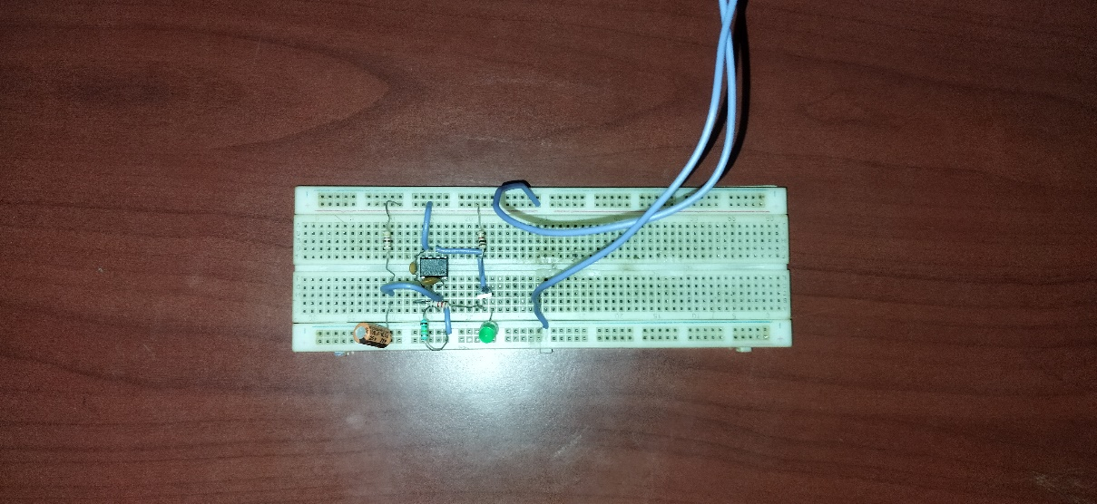

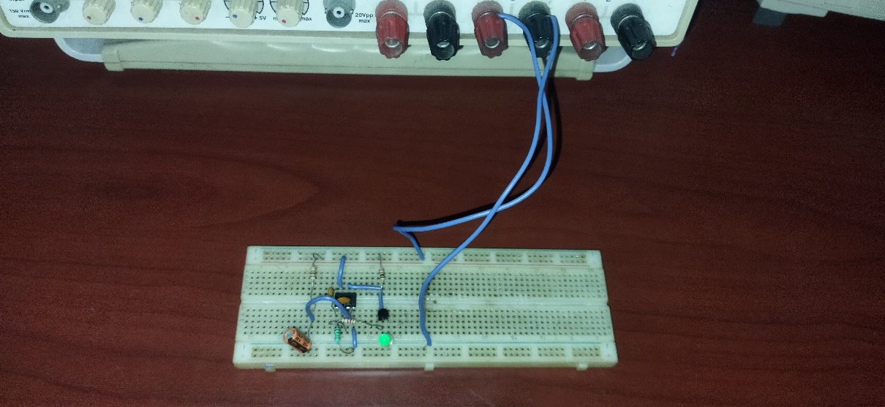

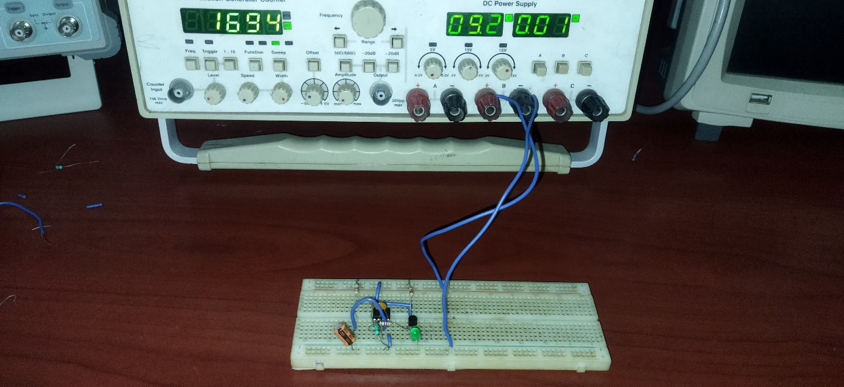

Here we are going to see how the circuit works when an **incoming call** or **outgoing call** is made or when an **SMS is sent** or **received** or any **GPRS used.**

**IN THE PRESENCE OF A MOBILE PHONE:**

* **CASE 1:**

**LED IS “NOT GLOWING” IN THIS CASE.**

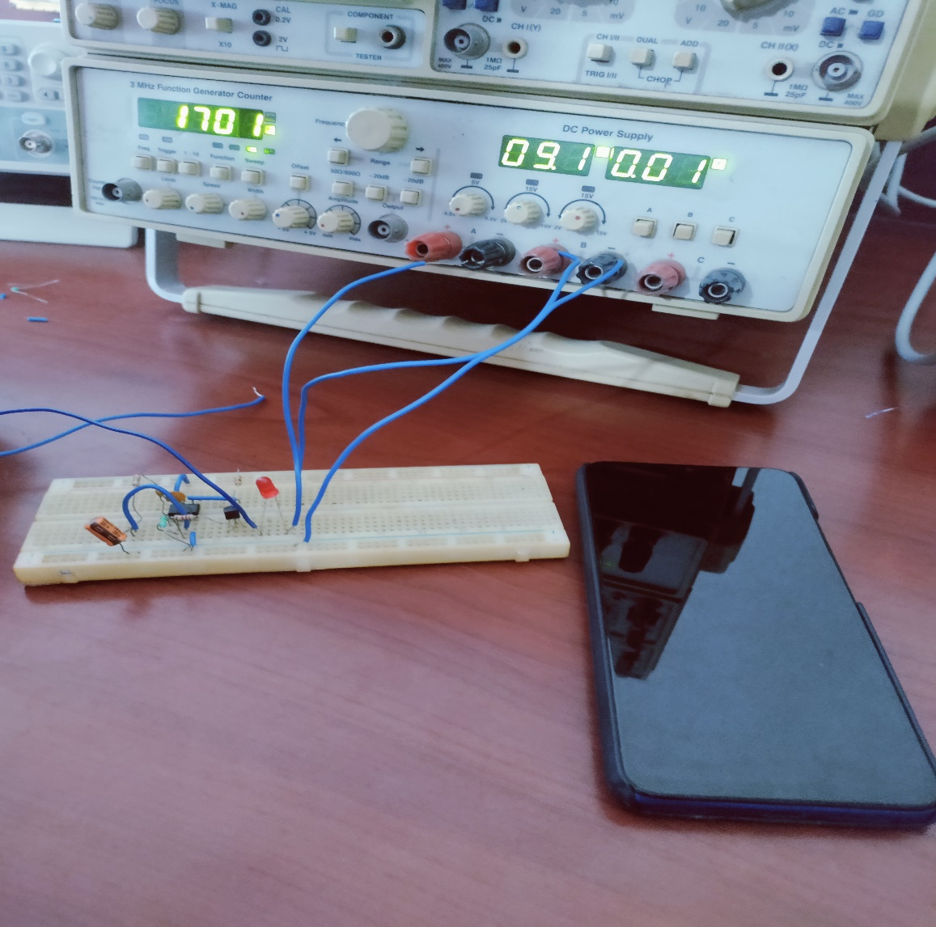

* **CASE 2:**

**LED IS “GLOWING” IN THIS CASE.**

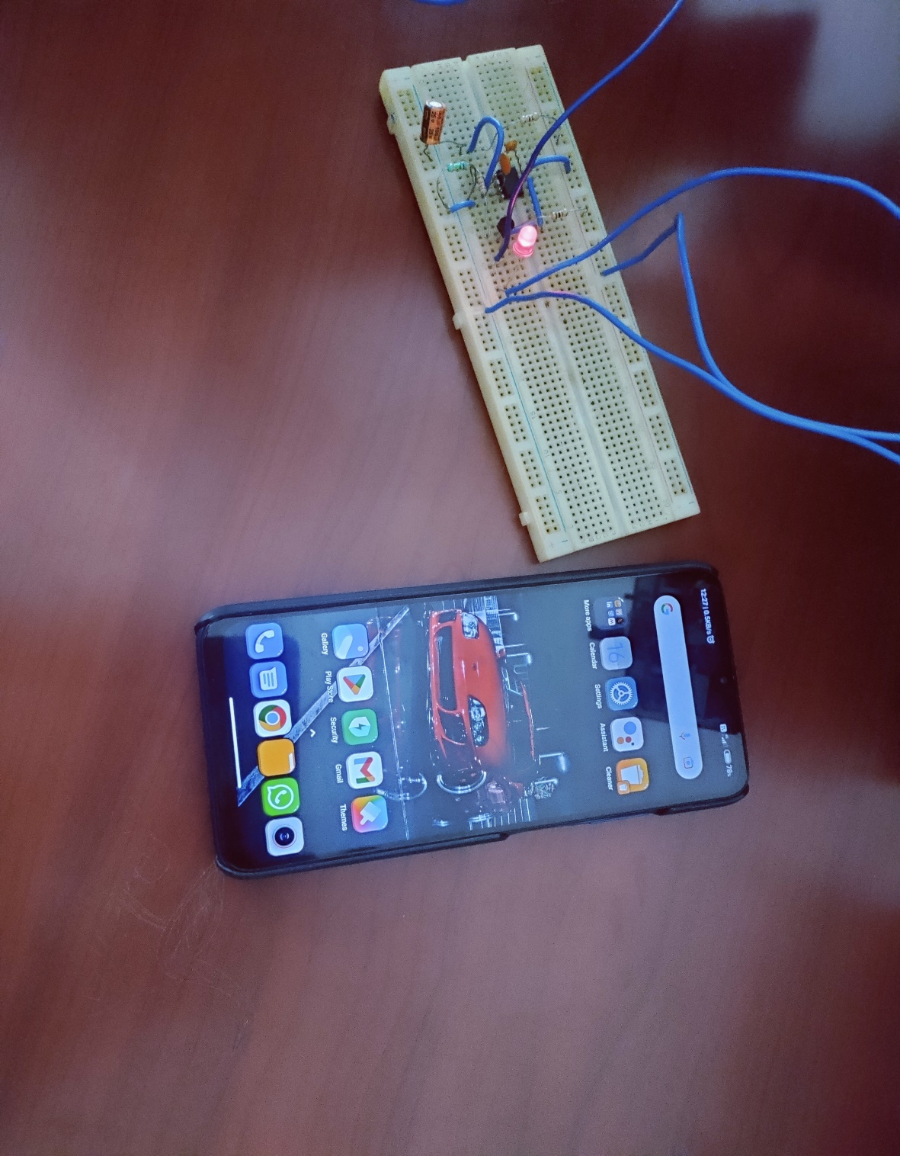

* **The LED glowing red in this case indicates the presence of a MOBILE PHONE.**
* **CASE 3:**

**LED IS “GLOWING” IN THE PRESENCE OF A MOBILE RECEIVING AN INCOMING CALL.**

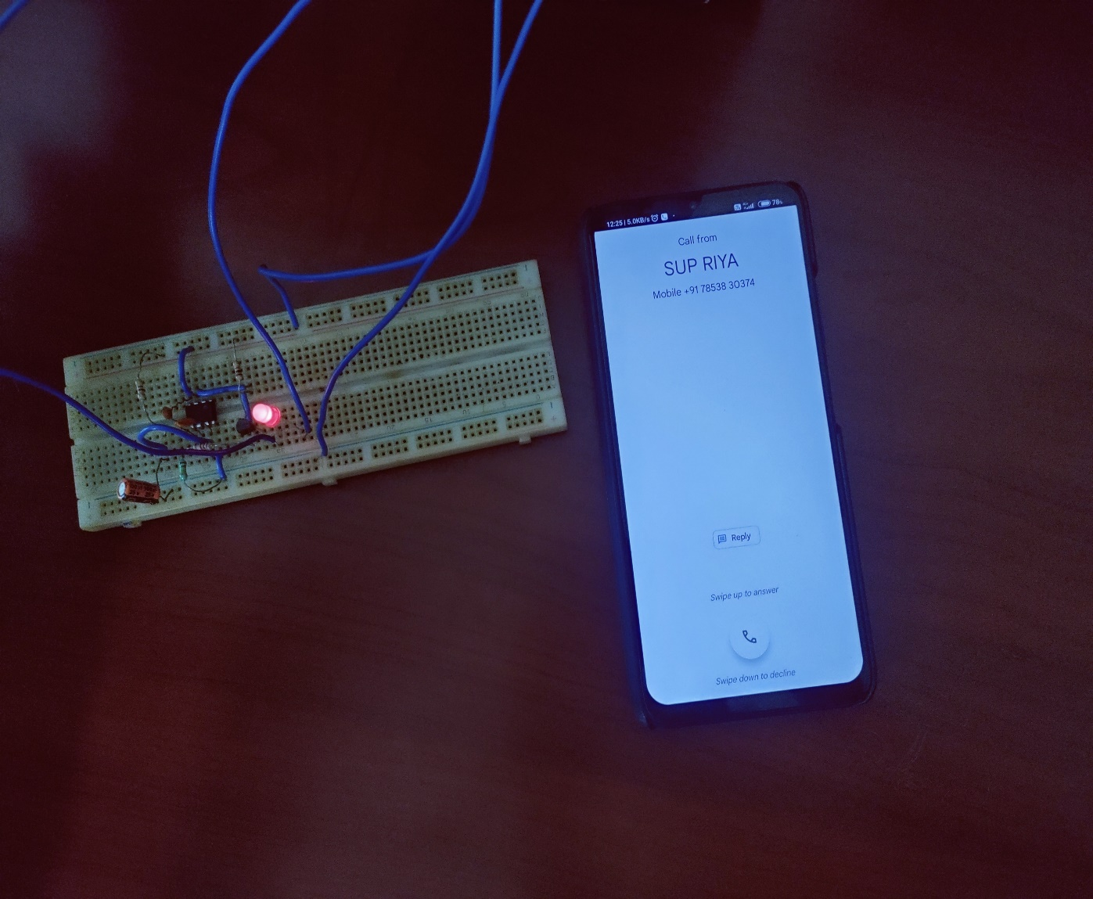

* **CASE 4:**

**THE LED IS “GLOWING” IN THE PRESENCE OF A MOBILE PHONE RECEIVING AN INCOMING TEXT MESSAGE.**

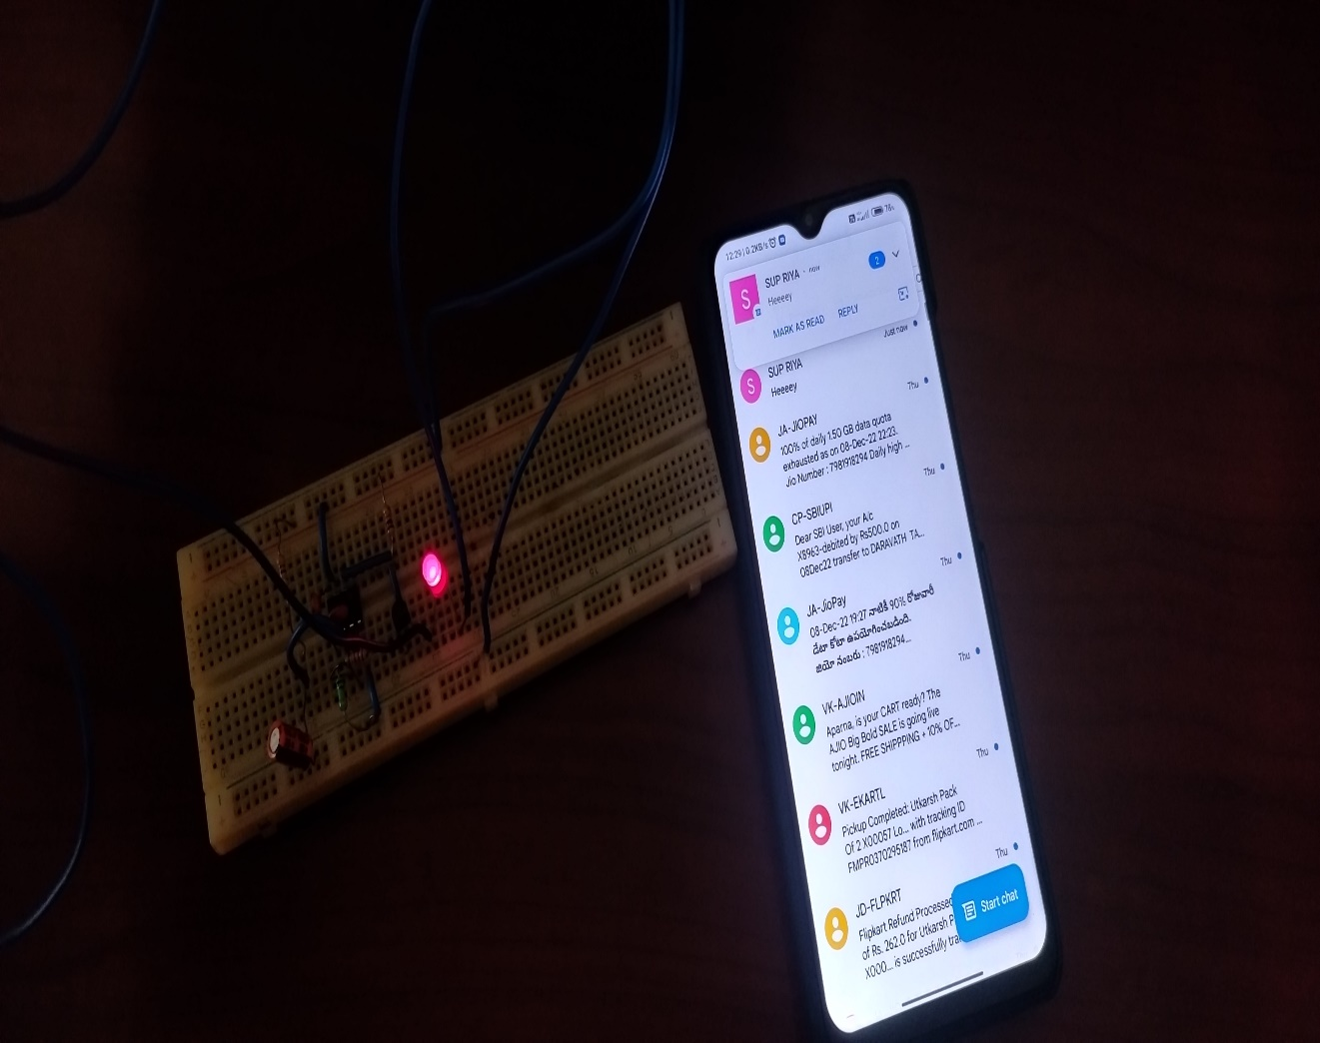

**OBSERVATION FOR IMPROVEMENT:**

In normal condition, when there is no RF signal, the voltage across the diode will be negligible. Even though this voltage is amplified by the transistor amplifier, yet the output voltage is less than the reference voltage. Since the voltage at non inverting terminal of the OPAMP is less than the voltage at the inverting terminal, the output of the OPAMP is low logic signal.

Now when a mobile phone is present near the signal, a voltage is induced in the choke and the input voltage is amplified by the common emitter transistor. The output voltage is such that it is more than the reference output voltage. The output of the OPAMP is thus a logic high signal and the LED starts glowing, to indicate the presence of a mobile phone. The circuit has to be placed centimeters away from the object to be detected.

APPLICATIONS:

* Examination hall
* Conferences
* Military Bases
* Embassies

USES:

The cell phone detectors are mostly hand from a distance of one and a half meters. So, it can be used to prevent the use of Mobile Phones in Examination halls, Confidential rooms etc.

SUMMARY AND FUTURE SCOPE:

This pocket-size mobile transmission detector or sniffer can sense the presence of an activated mobile cellphone from a distance of one and-a-half meters. So it can be used to prevent use of mobile phones in examination halls, confidential rooms, etc. It is also useful for detecting the use of mobile phone for spying and unauthorized video transmission.

In this project we made an attempt to design a mobile detector which can detect both the incoming and outgoing calls as well as video transmission even if the mobile is kept at the silent mode. Our circuit has detected the presence of an active mobile phone even at a distance of about one and half a meter. It gave the indication of an active mobile phone by glowing the LED, according to the receiving frequency and by buzzing the sound of the buzzer. The alarm continues until the signal is ceases.

FUTURE SCOPE :

Trying to increase the detecting range of mobile bug to few more meters for observing wide ranges of area. In the future time this detector will be improved in all ways.

In future we could be able to detect any range of frequency over a meter of range and this will be very useful to detect the cell phones where the cell phones are prohibited.

THANK YOU.